🎨 Streamlit Mini Paint App Pro – Documentation
1. Introduction
The Streamlit Mini Paint App Pro is an interactive web-based drawing application designed to allow users to create, manipulate, and customize 2D shapes on a digital canvas in real-time. It is a versatile tool that demonstrates the integration of Python, OpenCV, and Streamlit for web-based graphics applications.
Users can draw various geometric shapes, control their color, size, and orientation, and see immediate visual feedback. The application is suitable for creative experimentation, teaching basic geometry concepts, or prototyping visual layouts.
Links
- GitHub Repository: MINI PAINT PRO
- Live Demo: MINI PAINT PRO

2. Features
- Multiple Shapes: Users can choose from Rectangle, Square, Circle, Oval, and Triangle.
- Shape Customization:
  - Fill color and border color can be selected independently.
  - Border thickness is adjustable to create different visual effects.
  - Shapes can be rotated to any angle for precise positioning.
- Dynamic Placement: Users can position shapes anywhere on the canvas using X and Y coordinates.
- Live Preview: Any changes to shape parameters (size, rotation, color) are immediately reflected on the canvas.
- Canvas Management:
  - Add multiple shapes to the canvas.
  - Undo the last shape added.
  - Clear the entire canvas at any time.
- Download Option: Save the final canvas as a PNG image for offline use or sharing.
- User-Friendly Interface: All controls are provided in a sidebar for easy access.
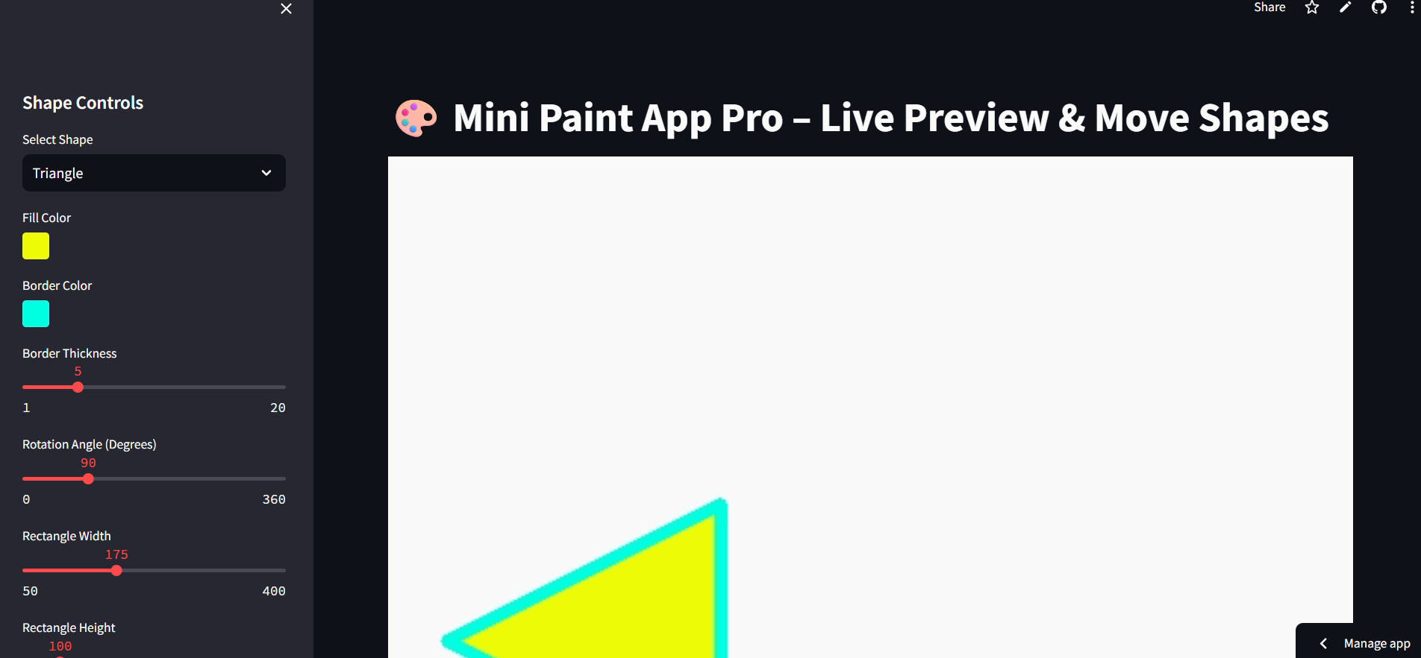
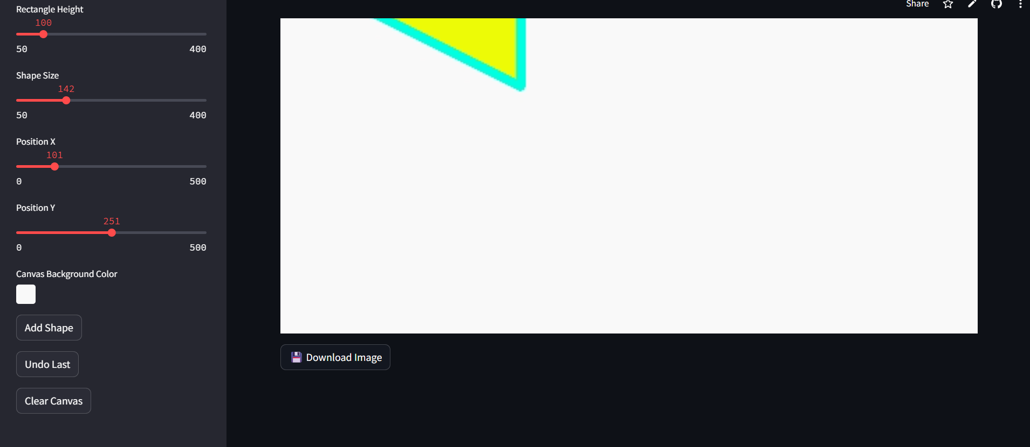
3. Technology Stack
Technology | Purpose
Python | Core programming language for logic and processing.
Streamlit | Provides an interactive web interface and UI controls.
OpenCV | Handles drawing shapes, rotation, and image processing.
NumPy | Manages canvas data as numerical arrays for efficient manipulation.
PIL (Pillow) | Converts images for download functionality.

4. Implementation Details
4.1 User Input
The application collects input through a Streamlit sidebar, including:
- Shape type
- Fill and border colors
- Border thickness
- Rotation angle
- Size (width and height for rectangles, general size for other shapes)
- Position coordinates (X and Y)
- Canvas background color
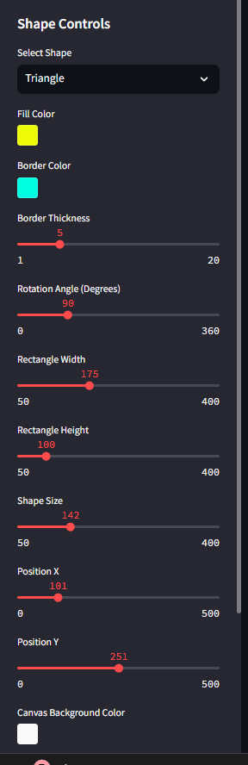
4.2 Canvas Rendering
- The canvas is created as a NumPy array, initialized with the selected background color.
- All shapes stored in history are drawn first to maintain previous work.
- Shapes are drawn based on the selected parameters using OpenCV functions:
  - cv2.rectangle and cv2.polylines for rectangles and squares
  - cv2.circle for circles
  - cv2.ellipse with overlay and masking for rotated ovals
  - cv2.fillPoly and cv2.polylines for triangles
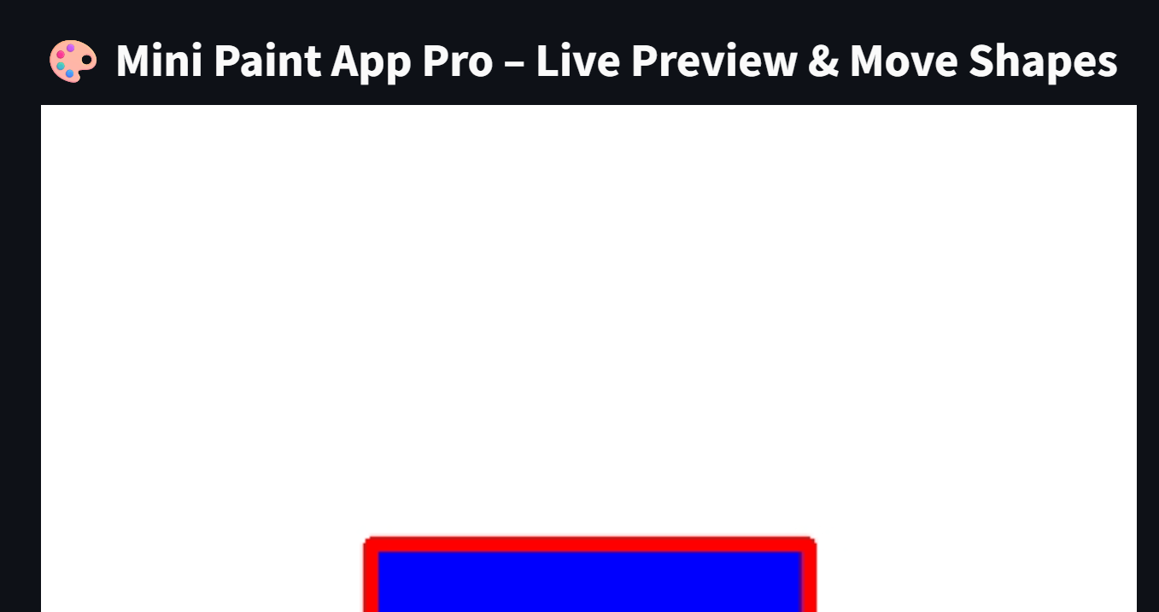
4.3 Live Preview
- The application continuously updates the canvas to show a live preview of the currently selected shape.
- Users can adjust parameters like rotation, size, or position and immediately see changes.
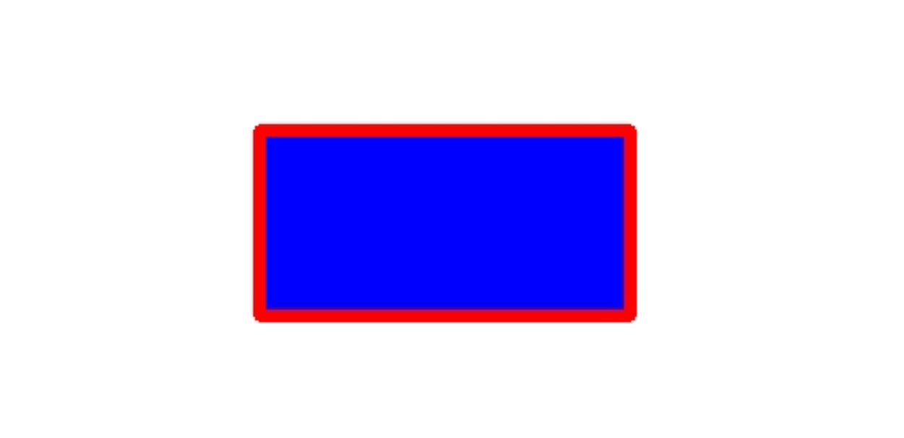
4.4 Shape Management
- Add Shape: Stores the shape in session history.
- Undo Last Shape: Removes the most recently added shape from history.
- Clear Canvas: Resets the canvas and clears all stored shapes.
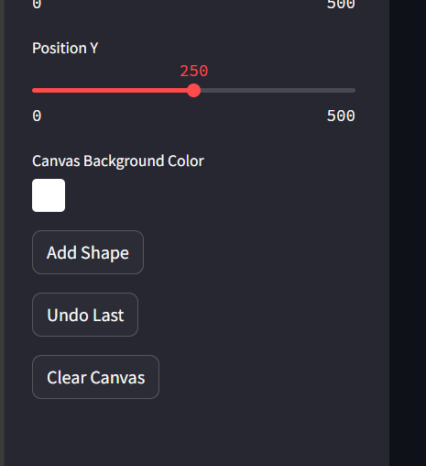
4.5 Download Functionality
- The canvas is converted from a NumPy array to a PIL image.
- Users can download the image in PNG format directly from the web app.
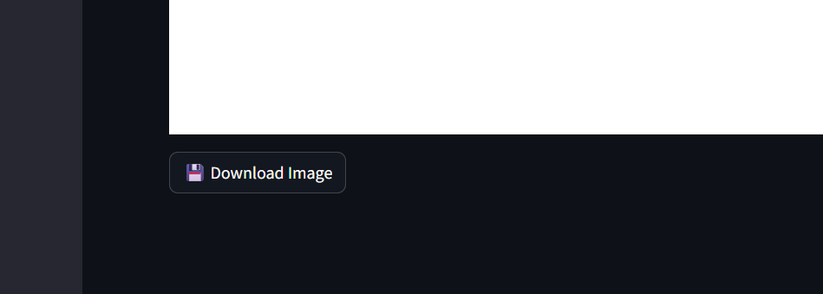
5. Workflow
- Select Shape: Choose the desired shape from the sidebar.
- Customize Shape: Set fill color, border color, thickness, rotation, size, and position.
- Preview Shape: Observe the shape live on the canvas before adding.
- Add to Canvas: Click “Add Shape” to store the shape in history.
- Manage Canvas: Use “Undo” or “Clear” as needed.
- Download: Save the final canvas as a PNG image for use.
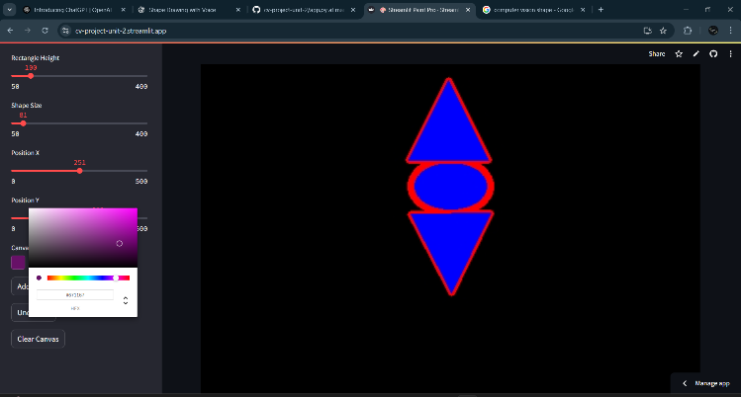
6. Benefits
- Provides a real-time, interactive drawing experience without installation.
- Demonstrates Python and OpenCV integration for graphics applications.
- Encourages experimentation with geometric transformations like rotation and scaling.
- Easy to use for both beginners and advanced users interested in digital design.

7. Conclusion
The Streamlit Mini Paint App Pro is a flexible and user-friendly drawing tool that combines Python, OpenCV, and Streamlit to offer a smooth interactive experience. Users can create custom shapes, manipulate them with precise control, and download their creations. The application highlights the potential of web-based interactive graphics and serves as a foundation for more advanced digital design tools.

